**Report**

**India’s Agricultural Crop Production Analysis(1997-2021)**

**Introduction :**

**Overview & Purpose :**

The report on India's Agricultural Crop Production Analysis from 1997 to 2021 aims to provide a comprehensive and visually engaging exploration of the agricultural sector in India. By leveraging the data visualization capabilities of Tableau, the report offers stakeholders a unique opportunity to gain insights into crucial aspects of crop production, including seasonal variations, regional distribution, and production trends over a 25-year period. It enables readers to intuitively analyze the data, identify growth areas, challenges, and make informed, data-driven decisions.

The primary purpose of this report is to deliver a clear and accessible understanding of India's agricultural crop production trends over a significant timeframe. The report aims to achieve the following objectives:

Insight Generation: By presenting data through visualizations, the report intends to extract valuable insights from agricultural data, making it easier for stakeholders to grasp key trends and patterns.

Interactive Exploration: By employing Tableau, the report offers an interactive experience, enabling readers to explore the data on their own. This fosters a deeper understanding of the complexities of Indian agriculture.

Data-Driven Decision-Making: The report supports evidence-based decision-making for policymakers, farmers, businesses, and investors involved in the agricultural sector.

**Problem Definition & Design Thinking**

**Empathy mapping :**

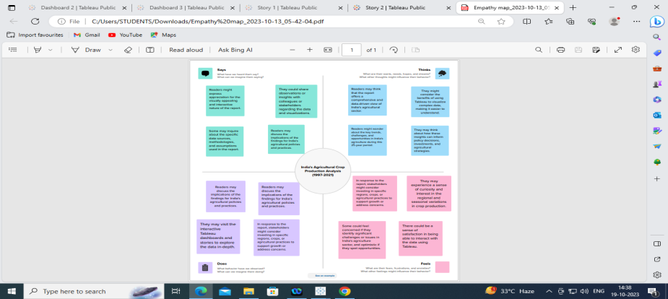

**Brainstroming:**

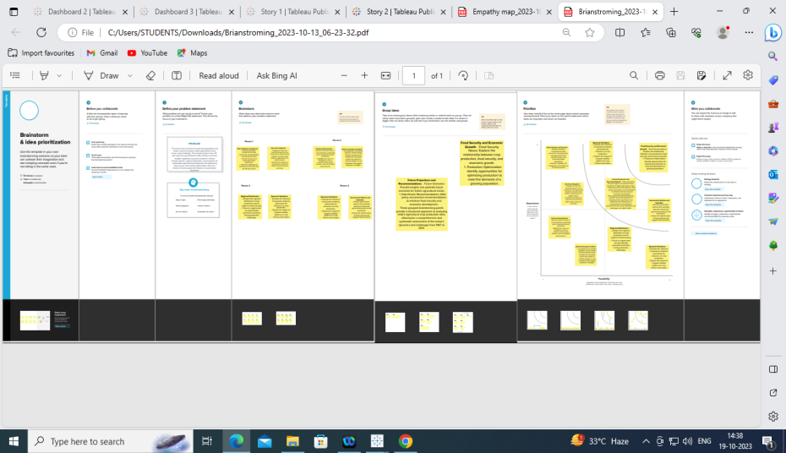

**Result:**

**Story 1:**

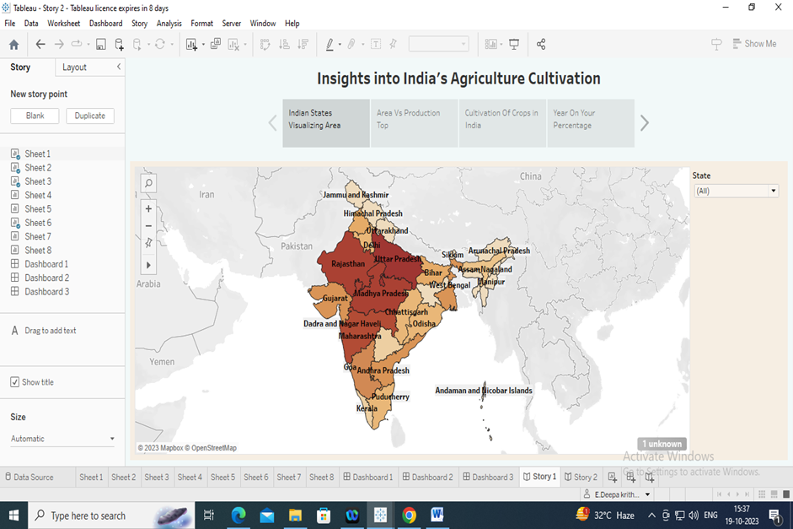

**Story 2:**

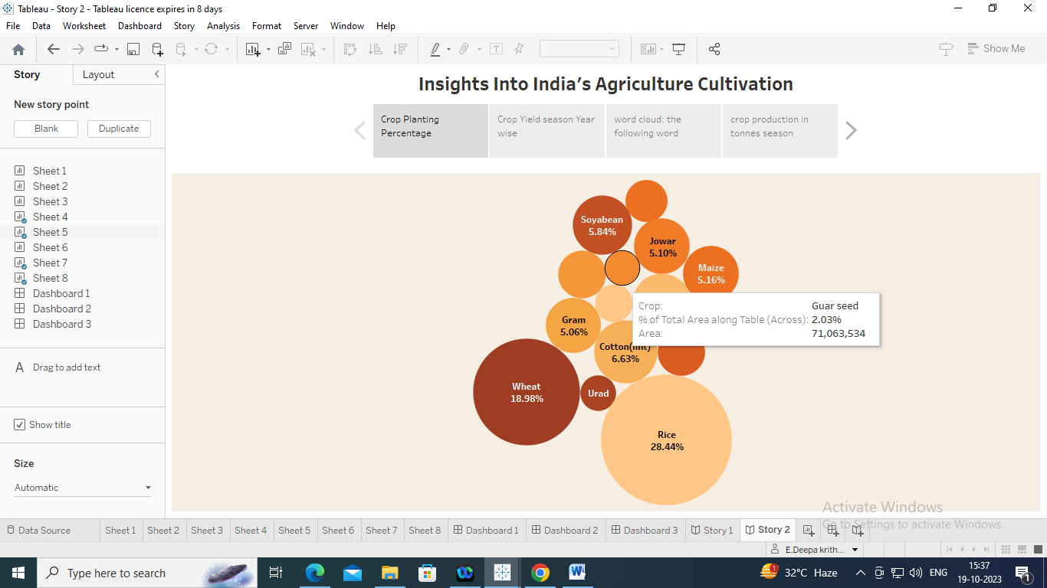

**Dashboard 1: Dashboard 2**

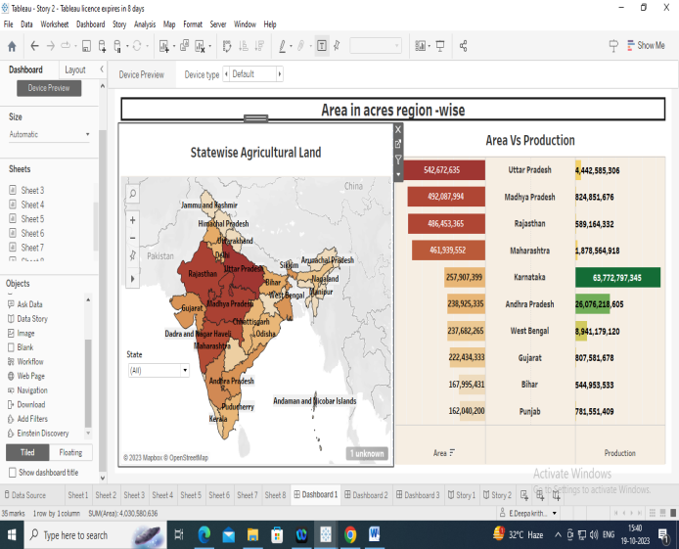 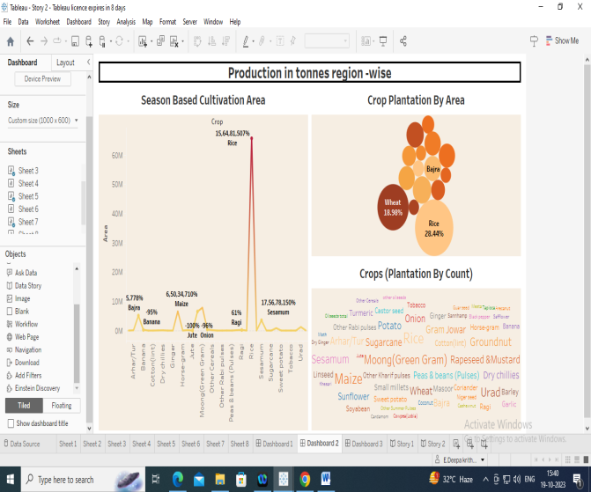

Dashboard 3

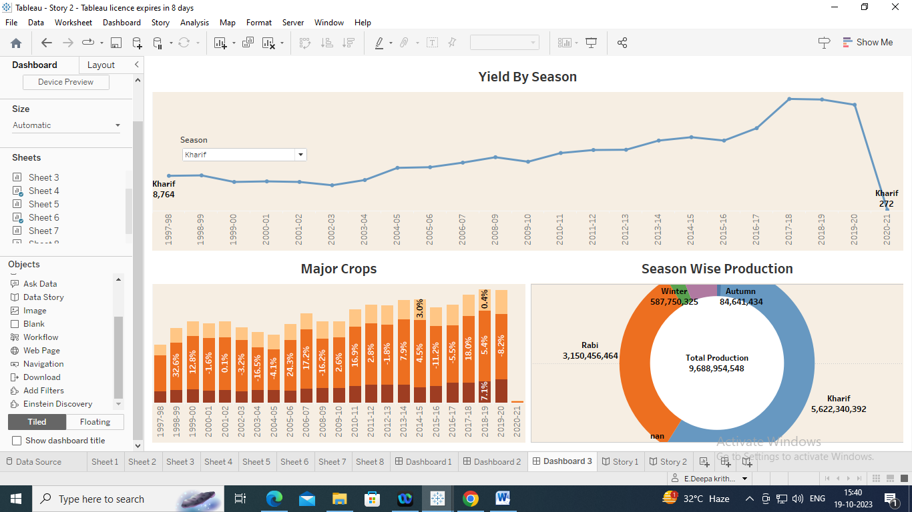

**Conclution:**

In conclusion, the report on India's Agricultural Crop Production Analysis spanning from 1997 to 2021 offers a compelling and informative journey into the world of Indian agriculture. Through the utilization of Tableau, this report accomplishes several significant goals.